# Chaotic Communication System Users Guide

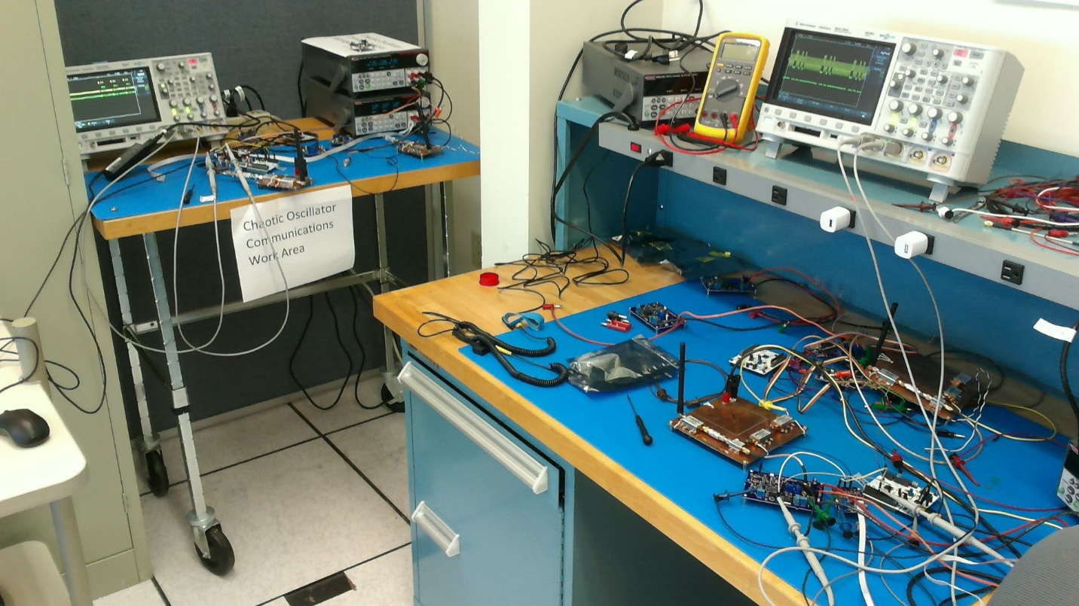

## Introduction

Included in this document is a user’s guide for setting up and using the chaotic communication system. A generalized block diagram of the system is included below. The primary subsystems of the design are the encoder, controller, oscillator, matched filter, and the decoder. Each of these subsystems are described in detail in their corresponding sections.

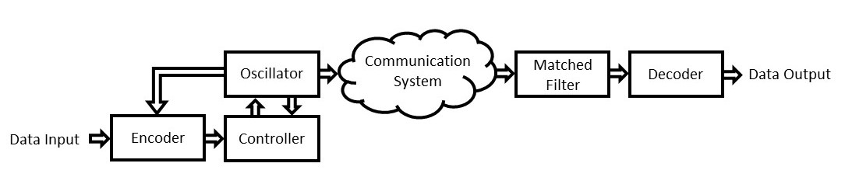 Generalized block diagram of baseband system for use in a communication system

## General Operation

This system is designed to send temperature data from an analog sensor. In order to maintain robust temperature data transmission, a single reading from the temperature sensor is taken and transmitted three times separated by a zero or NULL characters. These three readings are interpreted by the receiving GUI in order to determine if the data is valid. Each of these data sets are referred to as a frame. An example of a frame for 22 degrees Celsius would be below:

* 22 0 22 0 22 0 0

The consecutive zeros denote the end of a frame. This frame will be sent to the receiving computer and a python script will parse this data and compare the data.

## What Auburn University will deliver to NASA

* 2 microcontroller boards loaded with the necessary code
  + Encoder <front end>
  + Decoder <back end> (included header-mount inverter)
* 3 custom PCBs
  + Chaotic Oscillator
  + Oscillator Controller
  + Matched Filter
* Power cables
  + Custom cables for PCBs

## Power Supply

The required power supply specifications are listed below. Note that two separate power supplies should be used for the transmitting and receiving circuitry if used with a communication system.

* + Two separate differential power
    - ± 5V
    - 1000 mA (max)
    - 500-750 mA (typical)
    - Banana plug outputs

## Types of Connectors

1. Banana plug to ribbon cable

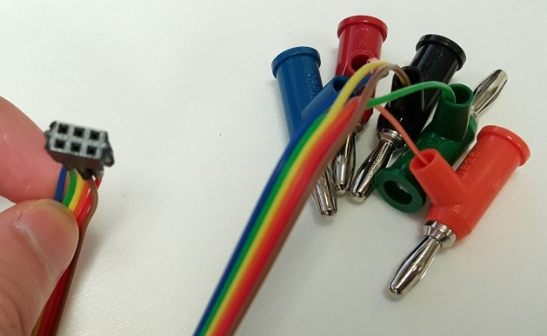

These ribbon cables are color-coded. These are used to power the boards. These will be provided.

* Red: +5V
* Black: GND
* Green: -5V
* Blue: -15V (unused)
* Orange: +15V(unused)  
  Note: These cables are **not** keyed! They can be plugged in backwards. Align the red cable with the “+5V” on the silkscreen next to the headers.

­­­­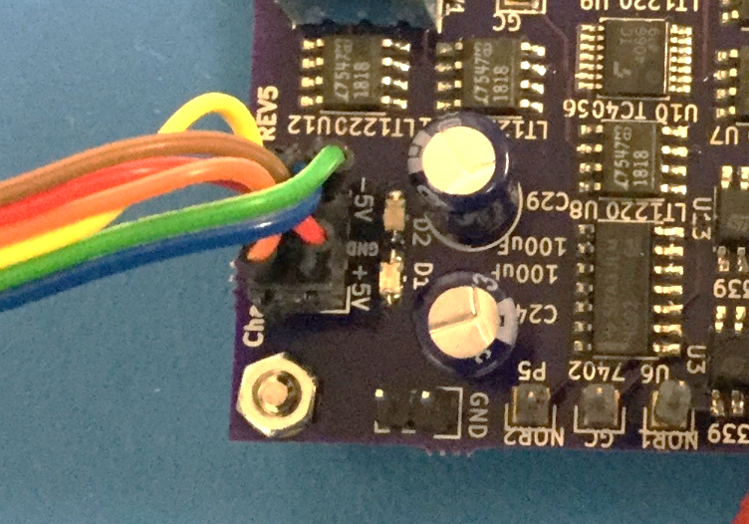

1. Mini-clip 🡪 mini-clip

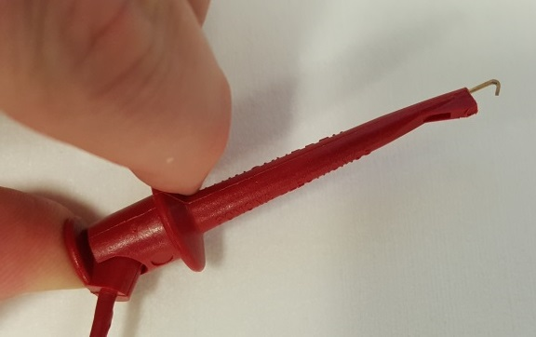

These are standard mini-grabber or mini-clip cables. They are used for connecting signal lines between the microcontroller, controller and oscillator boards. These are standard cables and will not be provided.

1. SMA connectors

SMA connectors will be required if interfacing to an external communication system. The custom designed PCB’s have 50 Ω matched SMA outputs/inputs were appropriate. SMA cables will not be provided.

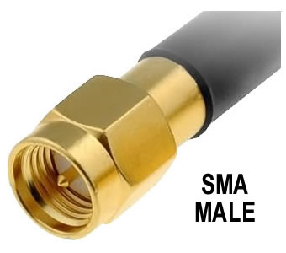

1. Microcontroller connections

Addition cables might be required for flashing new code on to the microcontrollers. The microcontrollers can be power by USB or through an external wall adapter. Data connections can be made using mini-clip cables and prototyping wire.

# System Structure

The system can be divided into multiple subsystems, as shown in the block diagram below. Each of these subsystems has been described in detail in their corresponding sections. Below is a detailed block diagram of the baseband transmitter side, the RF transmitter communication system, the RF receiver communication system, and the baseband receiver side.

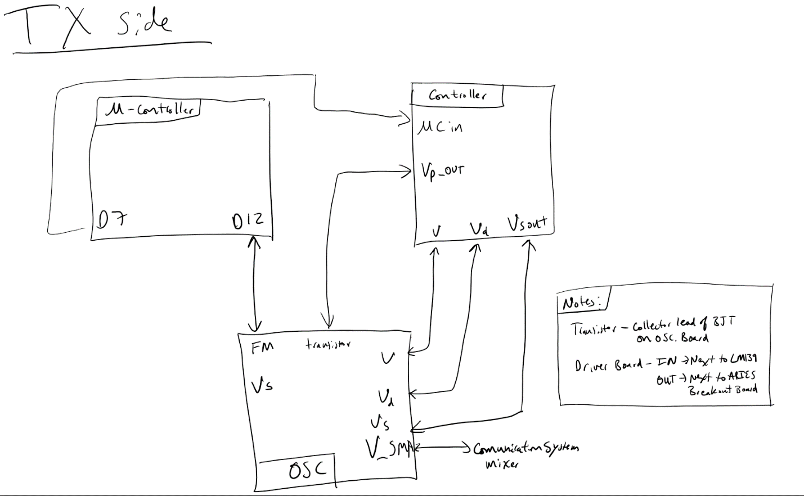

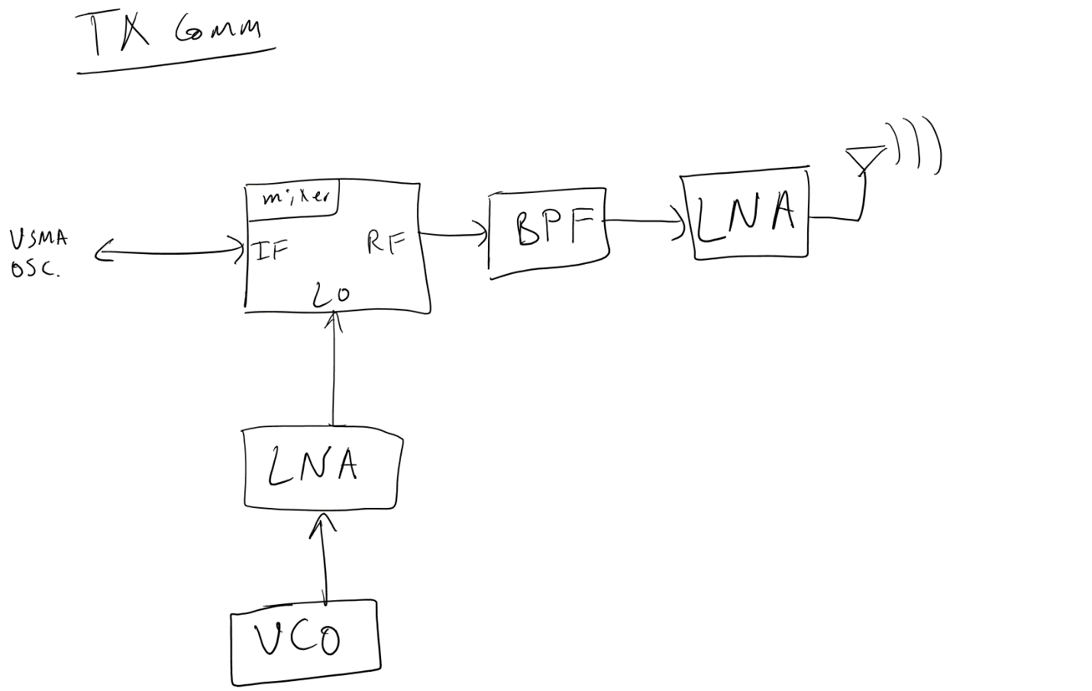

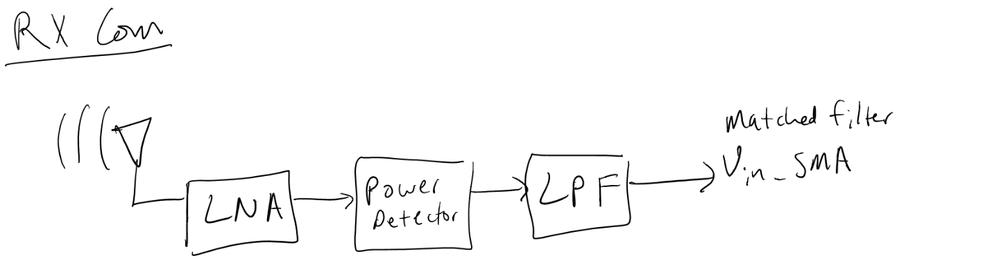

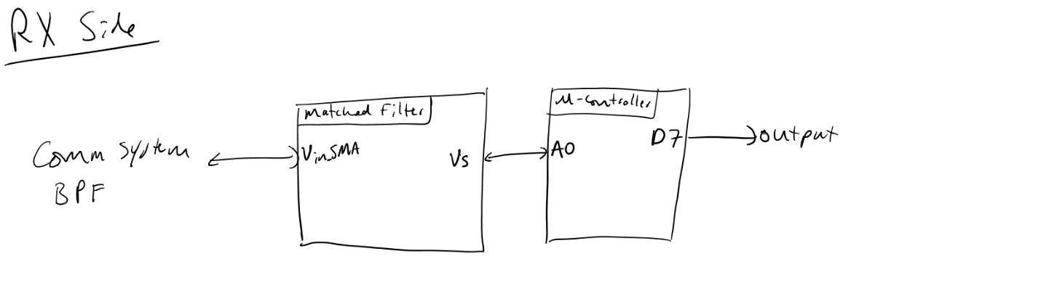

# Baseband SystemC:\Users\kev0004\AppData\Local\Microsoft\Windows\INetCache\Content.Word\Communication system block diagram.jpg

Generalized block diagram of baseband system for use in a communication system

The next section contains detailed information about each individual subsystem found in the block diagram.

## Oscillator

Description:

This subsystem is the chaotic oscillator. In order to encode information, this subsystem is controlled by the controller and microcontroller to encode the information. The information can be seen in the feedback signal, “Vs”.

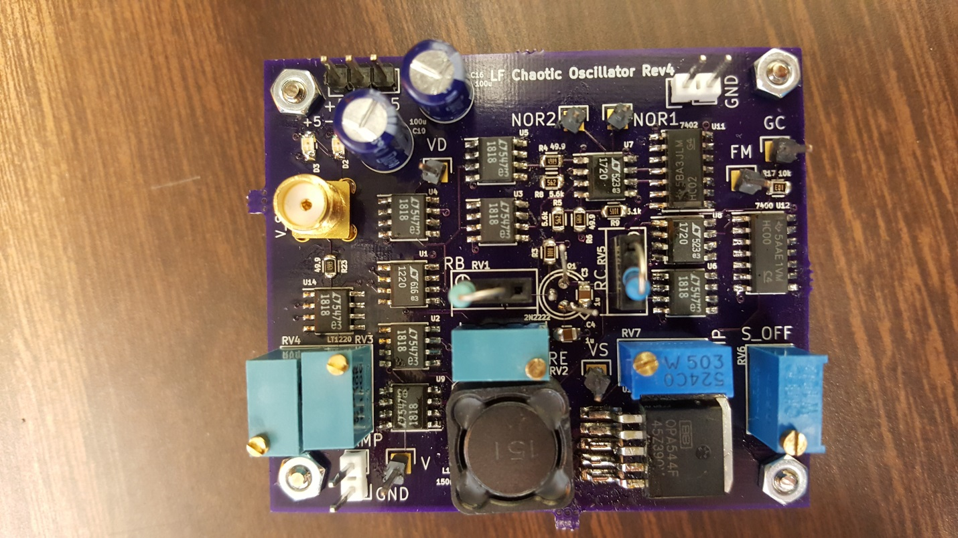  
New version of the chaotic oscillator Rev4

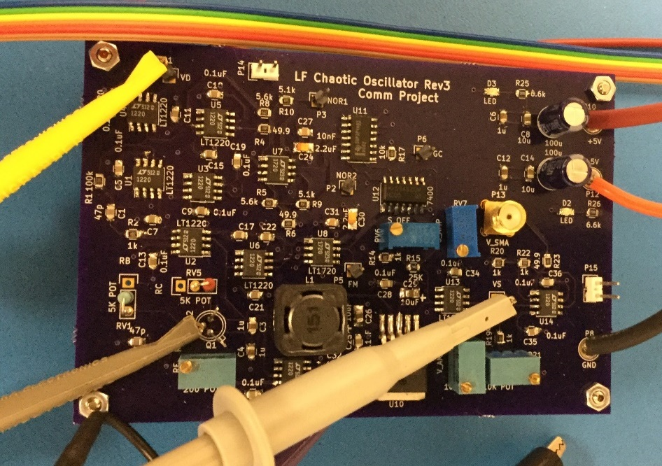  
Old version of the oscillator Rev3

This board provides multiple feedback signals to the controller and the microcontroller boards. The connections required are listed in the controller section.

When first starting up oscillator, some of the potentiometers might need to be manually tuned. The dark blue potentiometers labeled “Samp” and “Soff” can be used to tune the amplitude and the offset of the feedback signal, “Vs”. The signal will need to be tuned to approximately ±1V square wave. To further tune the chaotic oscillator, the 200Ω potentiometer can be used. The 200Ω potentiometer sets the bias resistor ratio for the transistor. The system will need tuning after it has sat for a long period. The following table has a list of these values that can be tuned. This is a good starting point but each board will vary.

|  |  |  |
| --- | --- | --- |
| Label on Silk Screen | Value (Ω) | Function |
| S_off | 400 | Offset of Vs |
| S_amp | 36k | Amplitude of Vs |
| R_e | 23 | Beta of differential equation |
| V_off | 4.4k | SMA offset |
| V_amp | 9.4k | SMA amplitude |

Table 1: List of tunable values of the oscillator board

## Encoder

Description:

This subsystem works with the controller to encode the information into the oscillator. The encoder generates the appropriate square wave to force the oscillator into one of two trajectories. One trajectory is mapped to a logic high and the other is mapped to a logic low. Instructions on how to flash the microcontroller are in the appendix. There are two buttons on the front end encoder. The black button is the reset, this must be pressed before any new code that was flashed will run on the microcontroller. The blue button is a toggle button that switches mode of operation. By default, the microcontroller starts in test mode, sending a continuous stream of 1’s and 0’s. The other mode is the temperature mode, which sends a temperature approximately every 2 seconds.

Testing Points

* D12: input of the folding mechanism (FM on oscillator) for edge counting
* D7: microcontroller output that controls the analog controller board
* A5: temperature sensor input

Temperature sensor

* Comes in a three pin package that can be plugged directly into the encoder
* Flat side facing you, left to right pins are 5V 🡪 output 🡪 GND
* The output lead can be bent to face outwards and connected to the input A5 on the microcontroller (see below where pin is bend away from pic)

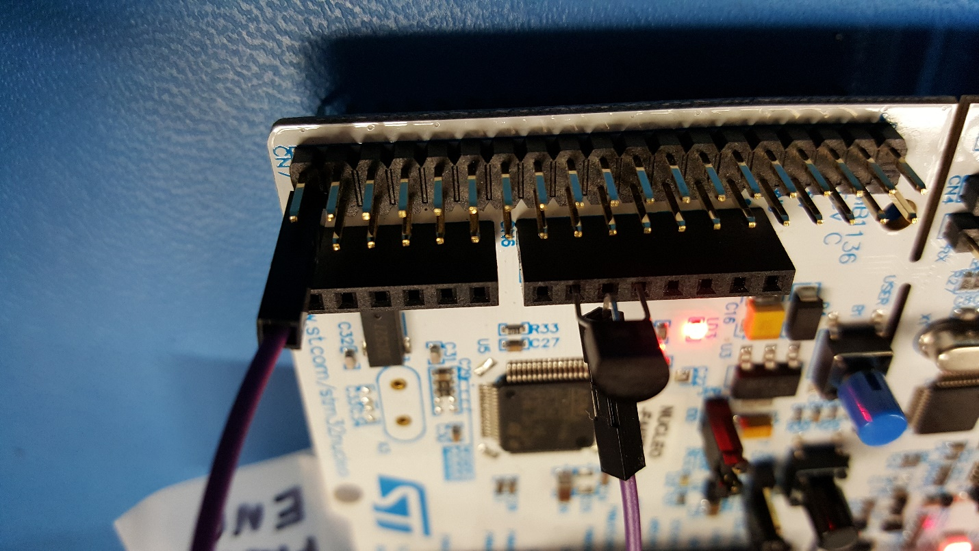

Connections:

*Connections are marked on pinout cards provided by STM in the packagaging included for easy viewing and reference.*

* V_FMfrom oscillator board 🡪 Pin D12 on microcontroller via mini-clip
* D7 on microcontroller 🡪 Driver board input via mini-clip

Power:

The microcontroller can be powered by USB with a jumper on JP1 (next to micro-USB port).

## Controller

Description:

This subsystem manipulates the chaotic oscillator’s waveform by using small perturbations. These perturbations steer the oscillator into two distinct orbits. One orbit is mapped to logic high and the other a logic low. The controller works with the encoder to imbed data in the chaotic oscillator.

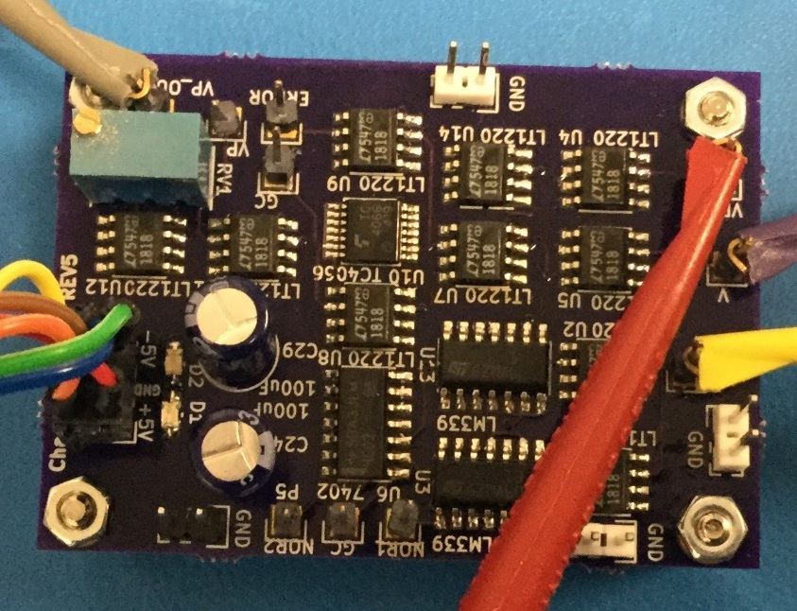

Old version of the controller Rev5

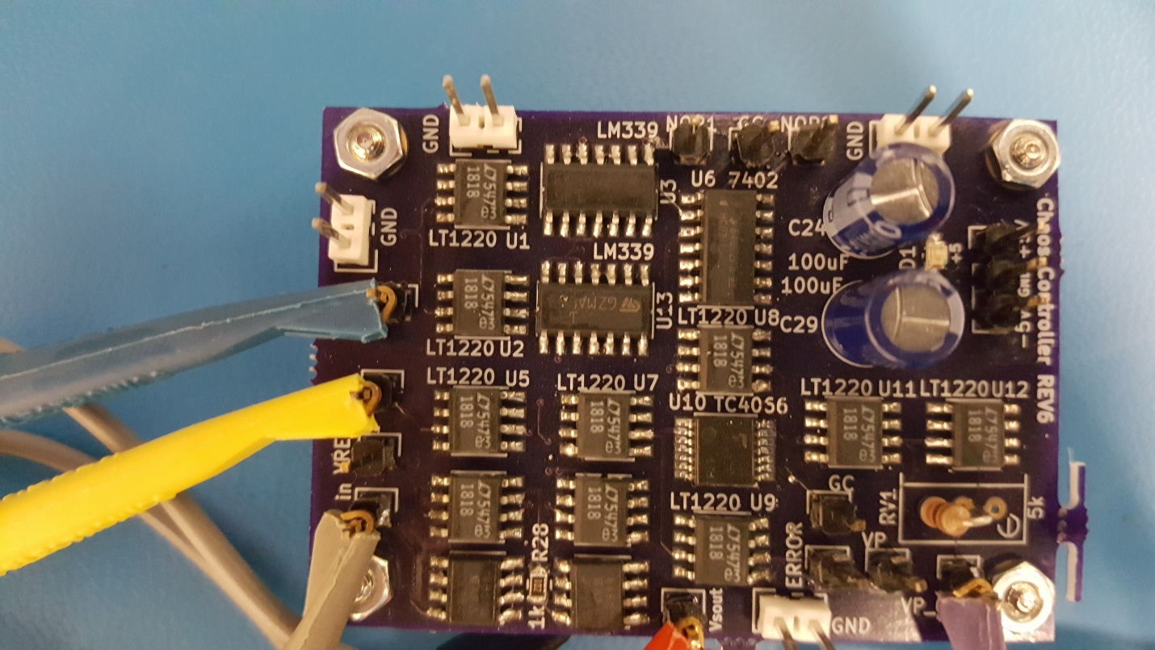

New version of the controller Rev6

Connections:

Power connections are made using provided banana ribbon cable.

* + Banana plug end at the power supply:
    - Red: +5V
    - Green: -5V
    - Black: GND
  + On the board:
    - Make sure the +5V red cable lines up on the “+5” marker next to the power pins on the silkscreen
* Data connections are made using mini-clip 🡪 mini-clip cables. Between oscillator, microcontroller, and controller board
  + V on the oscillator 🡪 V on the controller
  + VD on the oscillator 🡪 VD on the controller
  + VP_OUT on the oscillator 🡪 Collector lead of the transistor on the oscillator. This is located at the bottom right of the board (Shown in figure below with the red arrow on the unpopulated PCB). The transistor is mounted upside down, so that the control signal can be clipped in from the top of the PCB.
  + FM on the oscillator 🡪 D12 on the microcontroller
  + Vsout on controller 🡪 Vs on the oscillator
  + D7 on microcontroller 🡪 uC on controller

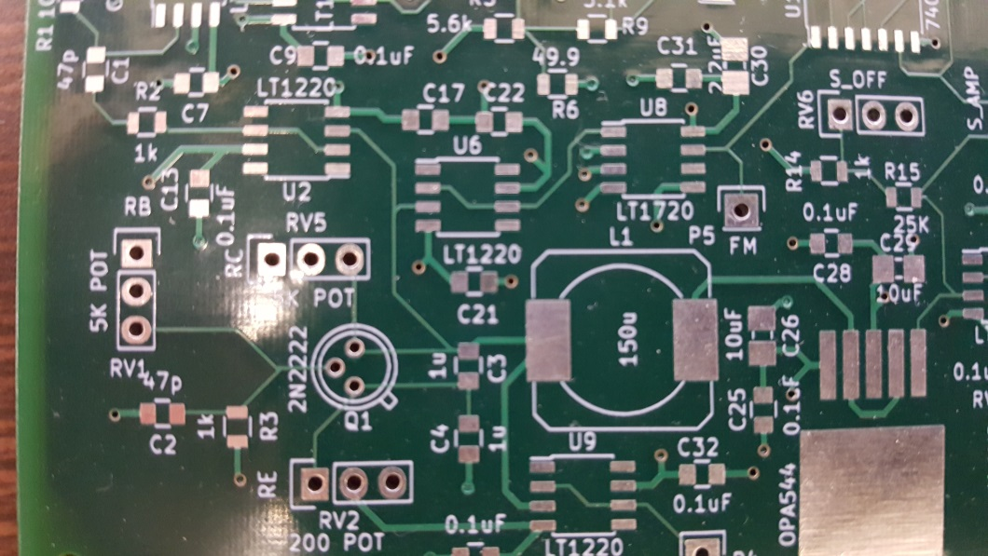



* Tuning the controller:
  + The controller has been modified with a static through hole resistor
  + If tuning is required, a 5kΩ potentiometer can be soldered into the slot where the through-hole resistor is located (near the output pin).
* Ideal tuning procedure (this can be an iterative process):
  + Tune the oscillator first using modifying the pots Samp and Soff while free running to ensure that Vs on the oscillator is near +/- 1V
  + Modify the pot Re (label Rv2) such that the oscillator appears to be chaotic
  + Connect the controller and microcontroller (flashed with front end code)
  + Enter testing mode on microcontroller (10101… pattern)
  + Tune Rv2 to make it appear that is similar to the Figure below:

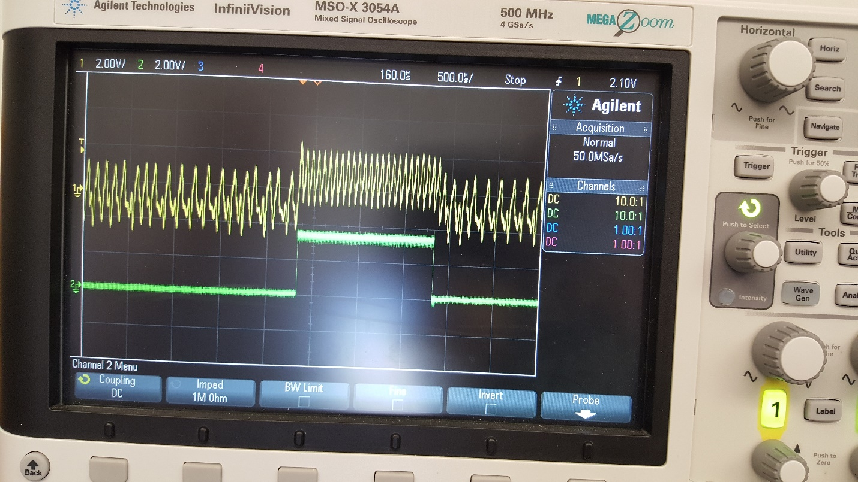

* + Note the high signal switches mostly periodically. You want to ensure that the high and low are also of equal length. The above example is from a start bit from the temp sensor code.

## Driver Board (no longer used with new controller Rev6 board)

Description:

Since the microcontroller operates on a 3.3V power rail, a small adapter is required to drive the 5V bias signal for the controller board. The board is pictured below.

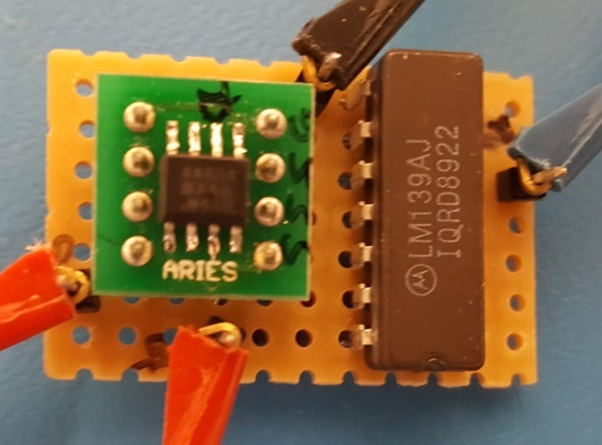

Connections (as reference by the figure above):

* Output (next to the ARIES breakout board on left) 🡪 “Vs” on the oscillator
* Microcontroller control signal 🡪 input (next to LM139 on right)
* 5V power supply rail is on the bottom
* GND power supply rail is on the top

## Matched Filter (Analog)

Description:

This subsystem detects the chaotic signal. A matched filter is the ideal detector of a signal in the presence of additive white Gaussian noise (AWGN). The input of the matched filter is the SMA connector labeled “Vin_SMA” on the silk screen or the header P9 labeled “Vin”. This input is 50Ω matched. The matched filter has two outputs, the recovered x(t) and recovered s(t). The x(t) output can be probed at the header pin labeled “Vnew.” It should have the same general form as the original V signal from the oscillator. It will not match the original output exactly since a matched filter maximizes the signal component of the output. Vnew will oscillate between -5V and +5V.

The s(t) output can be probed at the SMA connector labeled “VS_SMA” or the header P10 labeled “VS.” Like the matched filter’s input, VS_SMA is 50Ω matched. The signal oscillates between 0V and 3.3V. Compared to the original x(t) and s(t) from the oscillator, the matched filter’s outputs are delayed by a period. This behavior is the result of the filter’s delay stage. Furthermore, when used in the AM communication system described below, the outputs of the matched filter will be inverted. This is the result of the power detector used in receiver and not a problem with the filter.

The output of the matched filter is taken from “VS”. This signal is fed to the microcontroller where the data is decoded.

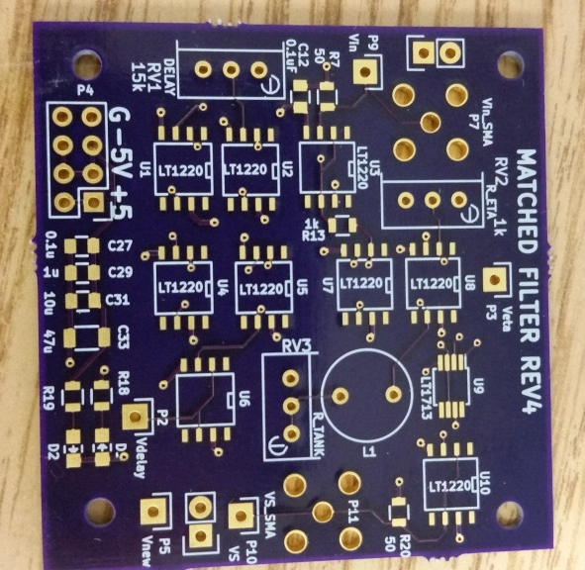

Connections:

* Communcation system 🡪 “Vin_SMA” P7 via SMA cable or Vin P9
* “VS” P10 or “VS_SMA” P11 🡪 Pin D12 on the microcontroller via mini-clip (if not using inverter)
* “VS” p10 🡪 inverter chip lead (inverter chip is shown below in next two figures, more info in decoder section)

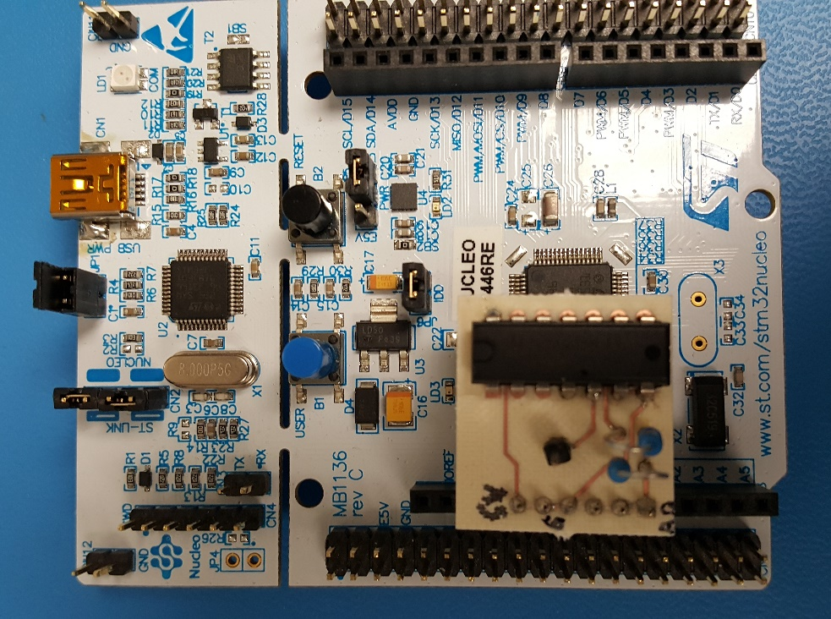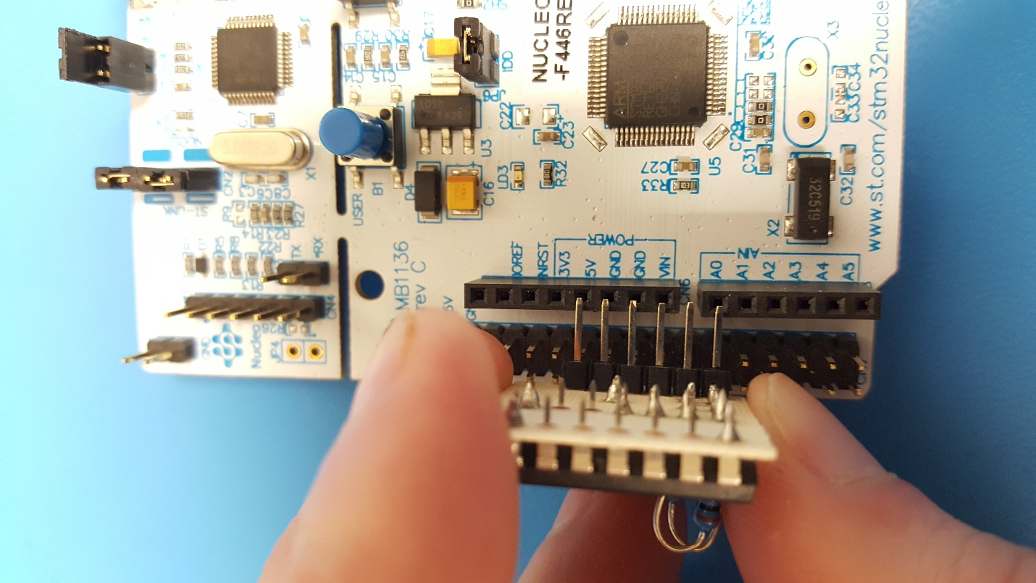

Tuning:

The matched filter needs to be manually tuned for optimal performance. This is done using the potentiometer “R_ETA”. R_ETA controls the magnitude of the output of the filter’s integrator stage. When tuning R_ETA, the integrator’s output can be probed at header P3 labeled “Veta.” Veta will have the same general form as the s(t) ; however, it will not be a square wave. The magnitude will tend to fluctuate somewhat. In order for the filter to operate properly, Veta needs to be centered close to zero. The magnitude of the Veta does not need to be exact. The main concern is that the integrator does not rail. If it does, the small fluctuations in Veta can be magnified enough that errors will start to appear at the filter’s outputs. Figure 1 shows an example of Veta when the integrator rails (notice the flat edges near the power rails of the op amp). If this occurs the potentiometer‘s resistance needs to be increased. Figures 2 and 3 show two examples of Veta after the resistance is increased more and more. The waveforms in either Figure 2 or 3 are acceptable; however, the waveform in Figure 2 is preferable.

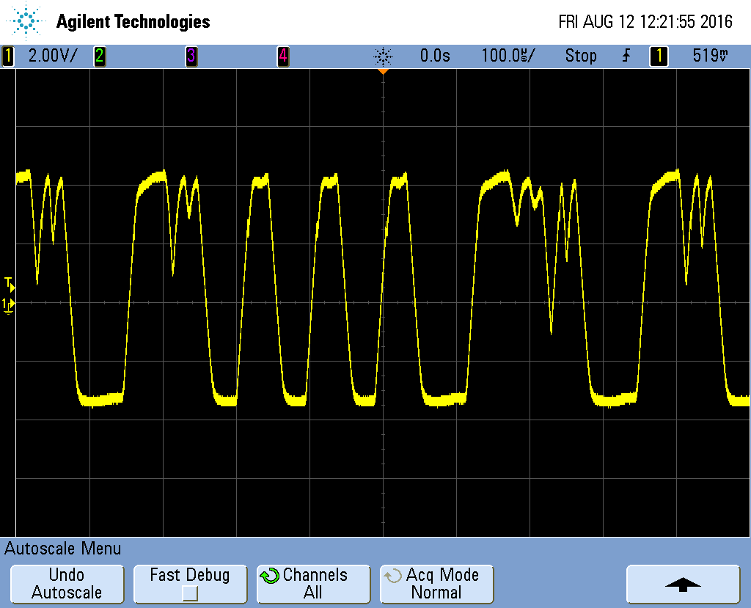

Figure 1: Veta when the integrator rails

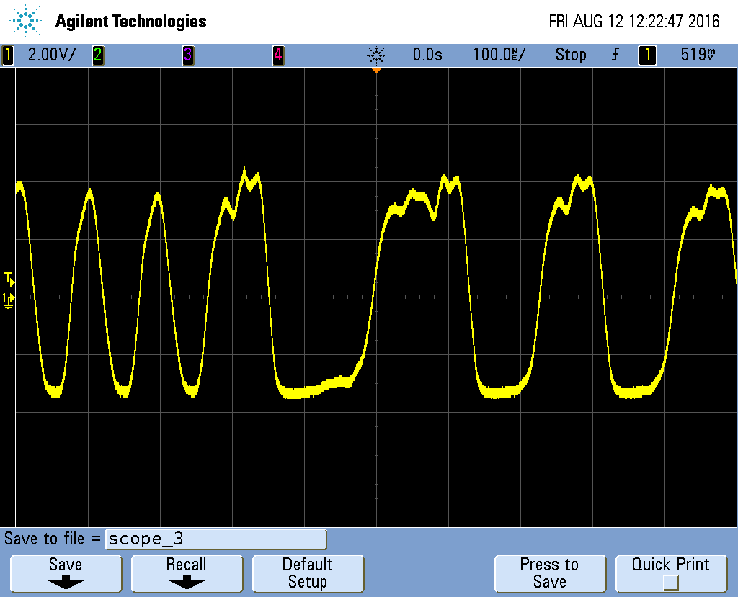

Figure 2: Preferred Veta waveform

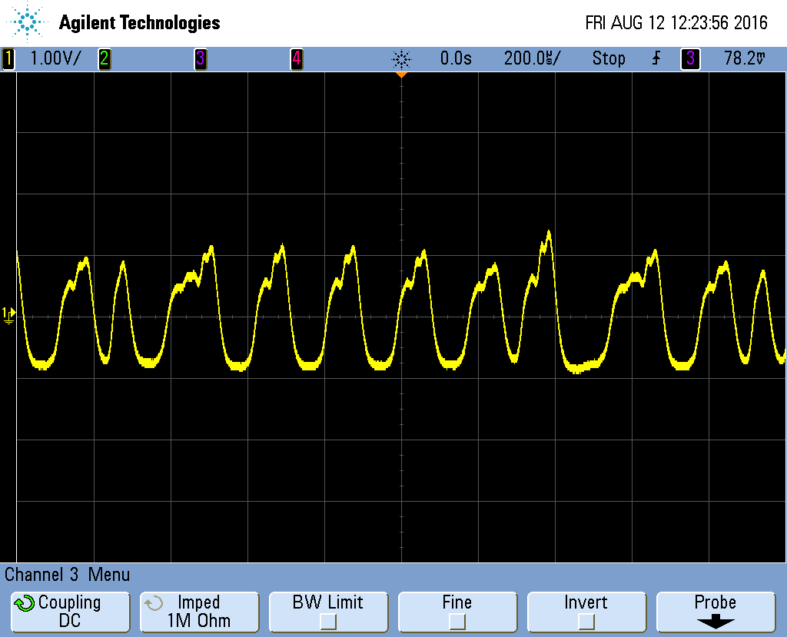

Figure 3: Acceptable Veta waveform

## Decoder

## Decoder

Description:

This subsystem recovers the encoded information from the matched filter. The microcontroller takes the information received by the matched filter, and decodes the signal to produce the original bit stream.

Testing points:

* D7: Output of microcontroller that is sent to the laptop
* D2: Clocking of the sample from data received (a sample is taken at each edge, rising or falling)
* D9 and D7: Bridged to maintain stable output regardless of received signal strength

Connections:

*Connections are marked on pinout cards included for easy viewing and reference.*

* “VS” P10 🡪 A0 on the microcontroller via mini-clip (if not using inverting stage)
* Scope on Pin D7 via mini-clip (to view decoded bit stream)

Power:

The microcontroller can be powered by USB with a jumper on JP1 (next to micro-USB port).

Inverting Stage:

This board is required for use with temperature sensor. This stage plugs directly into the back end microcontroller. Make sure to line up the pins where the pin A0 is connected on the bottom pin (labeled in the figure below).

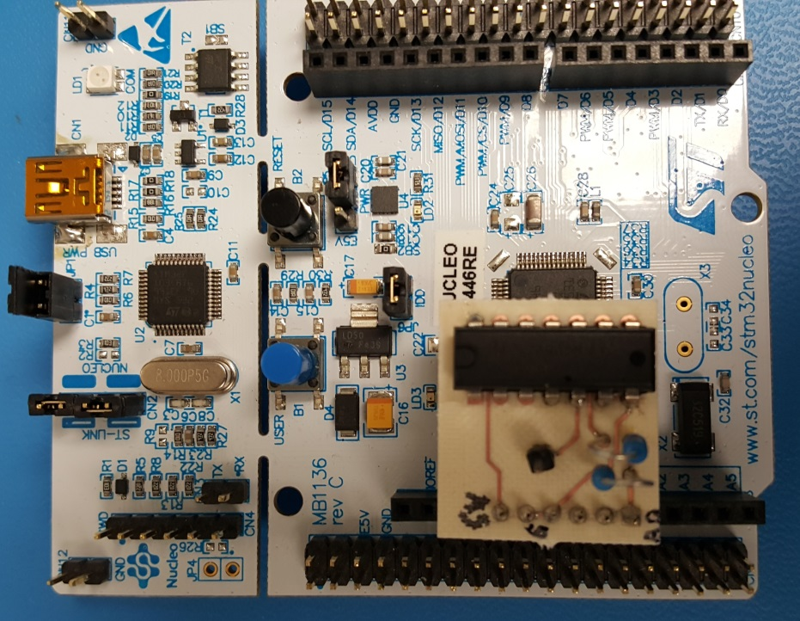

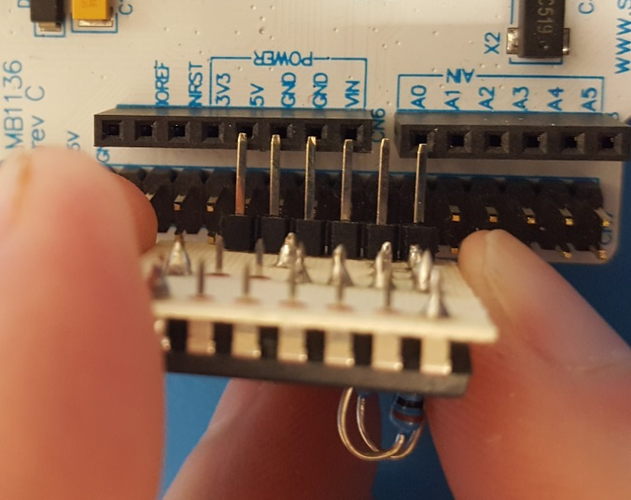

## AM Communication System

An example of the AM system we have used to demonstrate our system is shown in the block diagrams below. All of these types of components are manufactured by mini-circuits.

<http://www.minicircuits.com/homepage/homepage.html>

The chaotic oscillator is connected to the transmitter using an SMA cable. To avoid damaging the transmitter, the oscillator’s output needs to be greater than 0V but less than +1.7 V. The output can be calibrated using potentiometers. After oscillator’s output is calibrated and connected to the transmitter, both the oscillator and transmitter can be turned on. The voltage supply for all of the parts on both the transmitter and receiver needs to be ground and +5V.

The receiver can be connected to the matched filter using the coax to SMA cable. The main thing to keep in mind when using the receiver is that the output of the power detector is logarithmic and inverting. As a result, the output of the power detect will look very different from the originally chaotic waveform. However, the matched filter can compensate for the logarithmic effects and an invertor or modification to the decoder code can compensate for the inversion

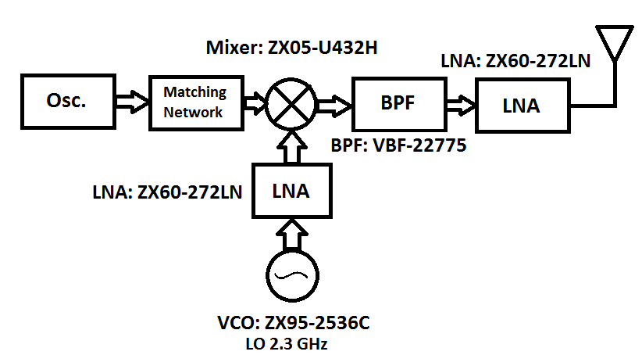

## Block diagram of the transmitting circuit

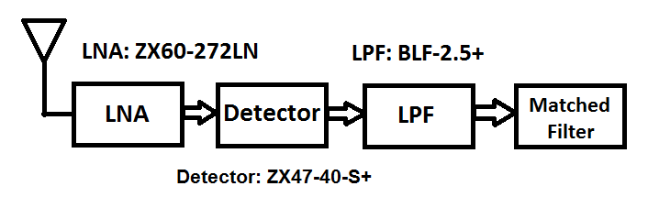

## Block diagram of the receiving circuit

# Sending Data

TX Side (a single temperature readings Yellow is the oscillator output and green is D6 the output of the microcontroller)

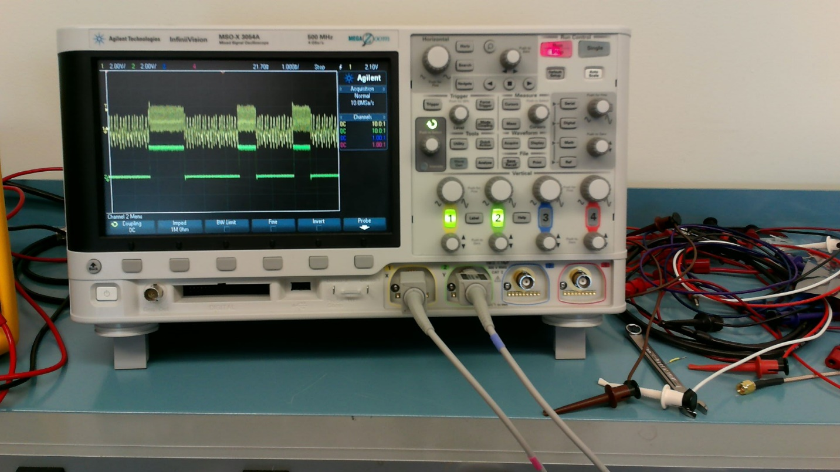

RX Side (three temperature readings)

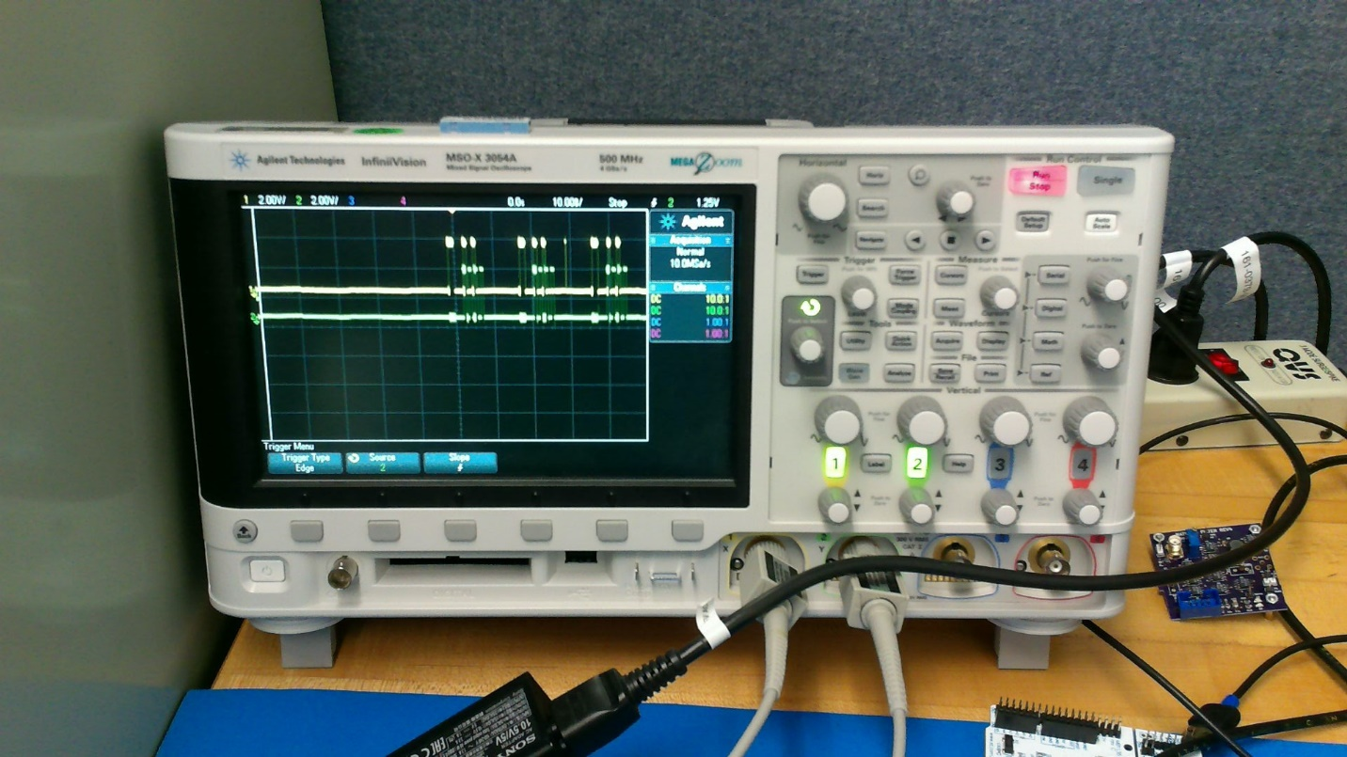

RX side receiving a single temperature reading (yellow: D7 output of controller and green is D2 is clock of microcontroller sampling)

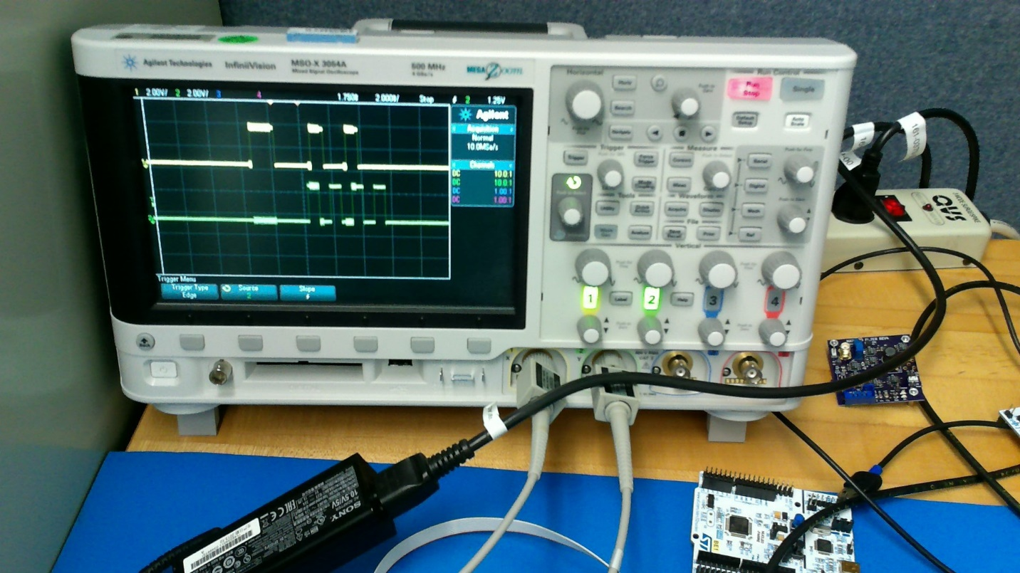

# Modifying the code:

## Front end:

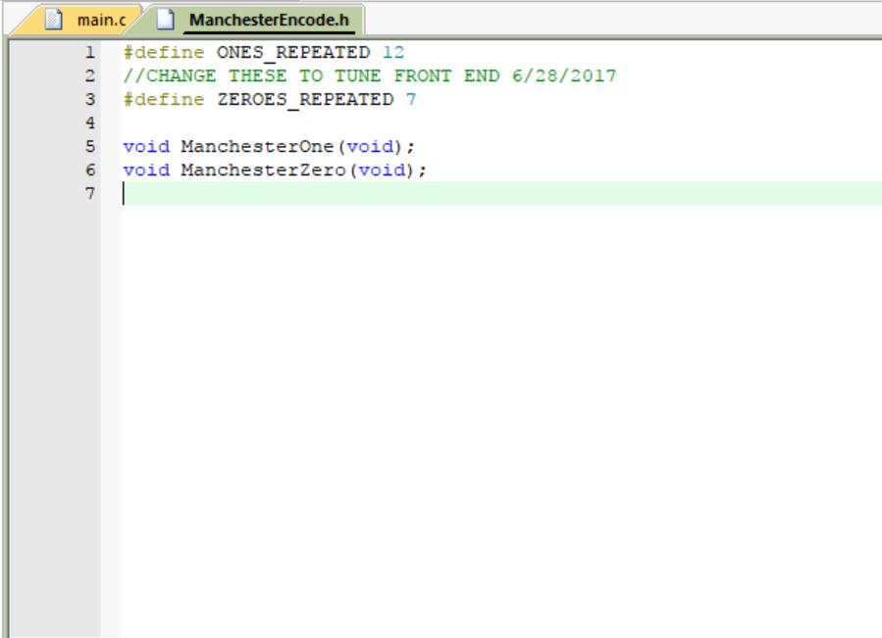

To change the length of the “zero” sent by the encoder, change ZEROES_REPEATED in this header file. To change the length of the “one” sent by the encoder, change ONES_REPEATED. If the header file cannot be found, make sure to compile the code.

## Back end:

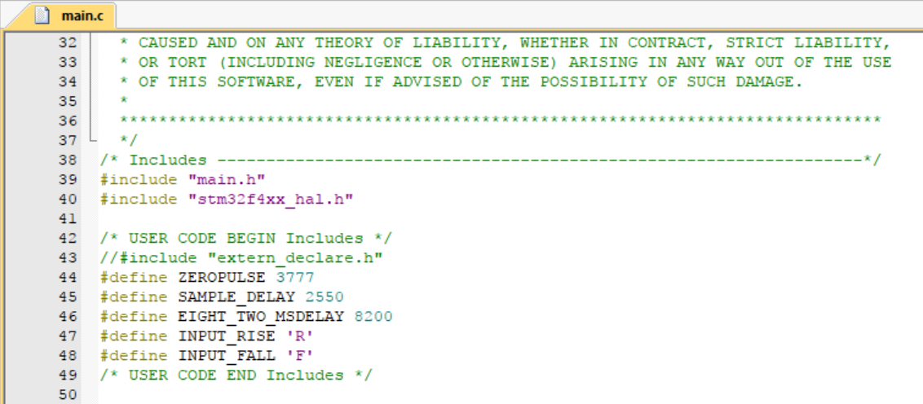

If the decoder shows some random spikes where there should be solid high and solid low, it may be that the threshold of what is detected as a zero pulse vs a one pulse should be altered. If there are spikes of a “high” value outside of the frame of data, or if any zero values in the data have high spikes, make this value smaller. If there are low spikes in any high pulses, make this value larger.

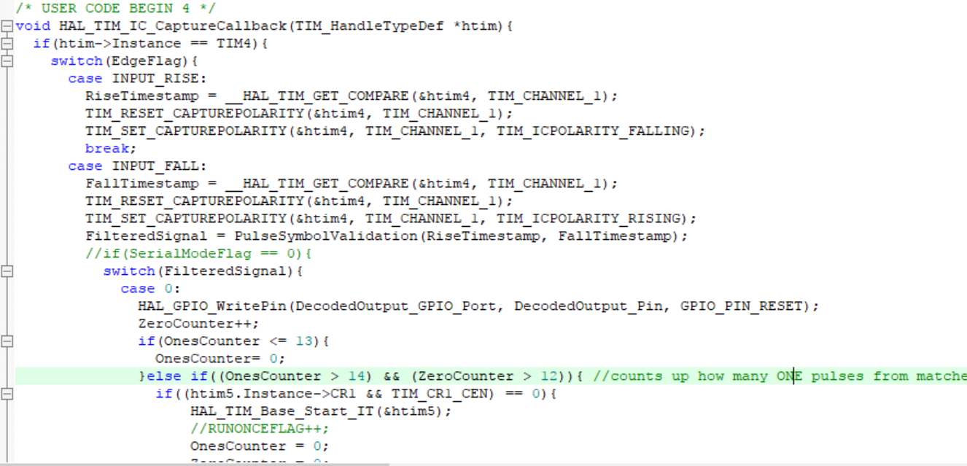

If the midpoint sampler (PIN D2) is starting late or early, one solution is to alter how the decoder detects the start sequence. In the highlighted conditional statement, the OnesCounter and ZeroCounter compare values determine how long the 1-1 and the 0-0 need to be for the sequence to be detected. Change these values and the values of the conditional statements “if OnesCounter <= 13” and the corresponding conditional for the zerocounter (below the code in this screenshot) to change where the midpoint sampler starts.

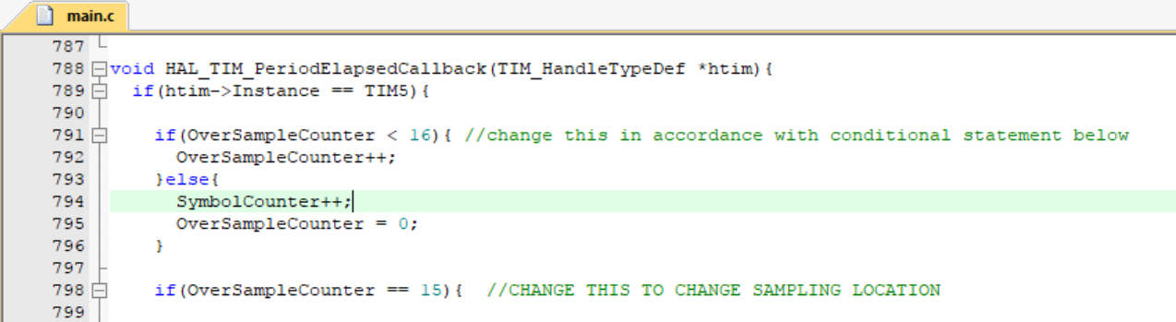

Another way to change the midpoint sampling is to alter the conditional statements regarding the variable “OverSampleCounter”. Both conditional statements shown need to be altered by the same amount when making a change (first conditional should be one larger than second conditional.) Making the values smaller will make the midpoint sampling earlier, and vice versa. Remember that PIN D2 shows the midpoint sampler, and a sample is taken on every edge (rising or falling).

The components used in Auburn’s test case are listed in the table below.

|  |  |  |  |  |
| --- | --- | --- | --- | --- |
| Communication System Parts | | | | |
| Part | Package | Quantity | Manufacturer | Part number |
| Antenna |  | 2 | Linx | ANT-2.4-CW-HW-SMA |
| VCO |  | 1 | Minicircuits | ZX95-2536C |
| Mixer |  | 1 | Minicircuits | ZX05-U432H |
| LNA |  | 3 | Minicircuits | ZX60-272LN |
| BPF |  | 1 | Minicircuits | VBF-2275 |
| LPF |  | 1 | Minicircuits | BLP-2.5+ |
| Power Detector | | 1 | Minicircuits | ZX47-40-S+ |
| GND plane boards | | 2 | AU | Custom In-House |
| Right angle Conn | | 2 | Linx | CONSMA010 |
| Connector |  | 2 | Amphenol-RF | 132169 |
| Connector |  | 3 | Linx | ADP-SMAM-SMAM |
| Connector |  | 1 | Pomona | 4288 |
| SMA cable |  | 3 | Amphenol-RF | 135101-01-06.00 |
| HEADER |  | 4 | Keystone | 24308 |
| HEADER NUTS |  | 4 | Keystone | 4707 |

Appendix: Flashing New Code to a Microcontroller

*Before doing anything else, go to the MDK-ARM Website <**[linked](https://www.keil.com/arm/demo/eval/arm.htm)>, register for the evaluation version of uVision, and install it. It is free for our use case.*

1. Open uVision, click the Project dropdown menu, then click Open Project.

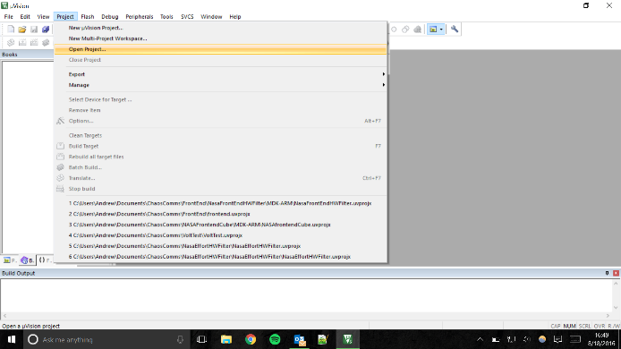

1. Navigate to the folder holding the project files. It will look similar to the picture below.

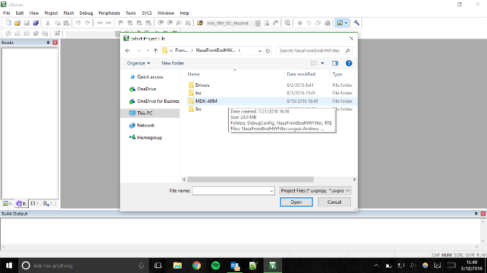

1. Find the .uvprojx file and open that. This is the project file, holding information on what files belong to this specific project and other related settings.

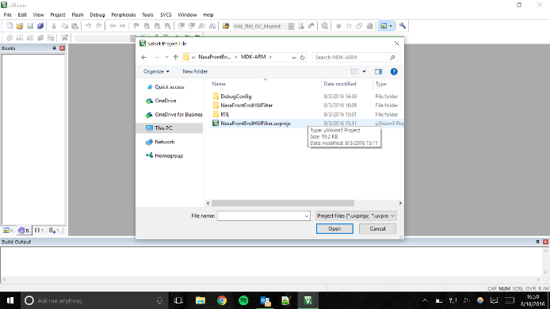



1. Click the Rebuild icon. This will generate the files to be flashed to the microcontroller.

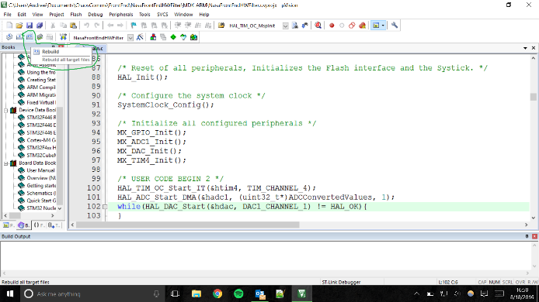

1. Click the Load icon. This will flash the new code onto the microcontroller.

